Bash Scripting

Bash scripting is the process of writing a series of commands in a plain text file for the Bash (Bourne Again SHell) terminal to execute automatically. Instead of typing terminal commands one by one, you bundle them into a single script file to automate repetitive tasks.
Core Components of a Bash Script
- The Shebang (#!/bin/bash): The very first line of the file. It tells your operating system to execute this file using the Bash interpreter.
- Commands: Any command you can type in a terminal (like cd, mkdir, ssh, or chmod) can be written inside a script.
- Logic Controls: Scripts can use variables, if/else statements, loops (for, while), and functions to perform complex logic.
Quick Example
Here is what a basic script (backup.sh) looks like:
bash
#!/bin/bash
echo "Starting file backup..."
cd ~/Documents
tar -czf backup.tar.gz ./ProjectFiles
echo "Backup completed successfully!"
Use code with caution.
Common Use Cases
- Automation: Automating routine tasks like backing up databases, system maintenance, or log rotation.
- Cloud & DevOps: Provisioning servers, updating software packages, or deploying code (e.g., configuring your AWS EC2 instance automatically).
- Text Processing: Searching, parsing, and filtering massive server logs or data files quickly.

What is Sanity Test?
In Bash scripting, a sanity test (or sanity check) refers to a collection of quick, high-level checks placed at the very beginning of a script to ensure that the environment, dependencies, and parameters are valid before executing any critical logic. Its purpose is to fail fast and exit gracefully if the execution environment is fundamentally broken.

Breakdown of the Commands
- free -m: Checks system memory (RAM) usage, displaying the values in Megabytes (MB).
- ps -ef: Lists every currently running process on the system in full-format detail to spot rogue or frozen programs.
- df: Displays the amount of available disk space on all mounted filesystems.
- du -sk *: Summarizes disk usage for all files/directories in the current path, showing sizes in Kilobytes (KB).

In AWS console created instance with the name Linux_server
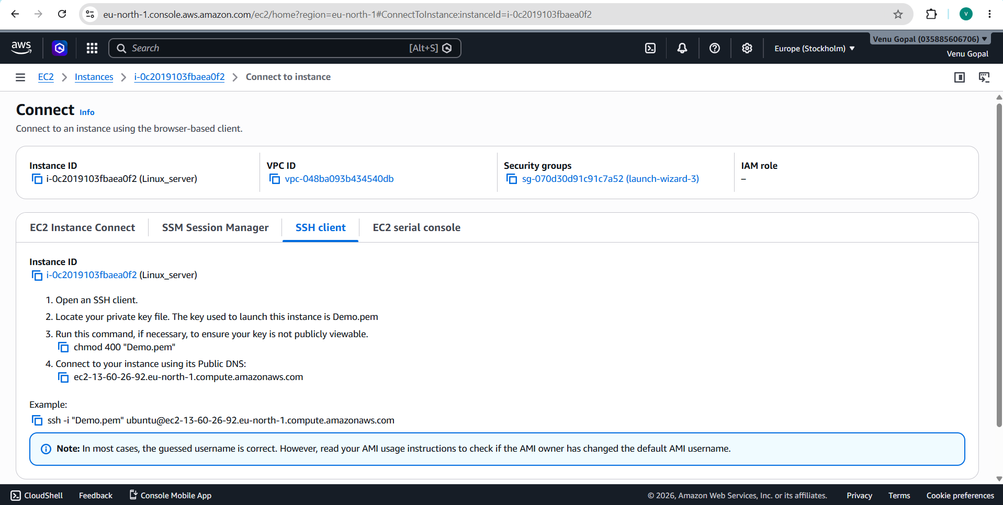

Login with SSH client detail in Git Bash
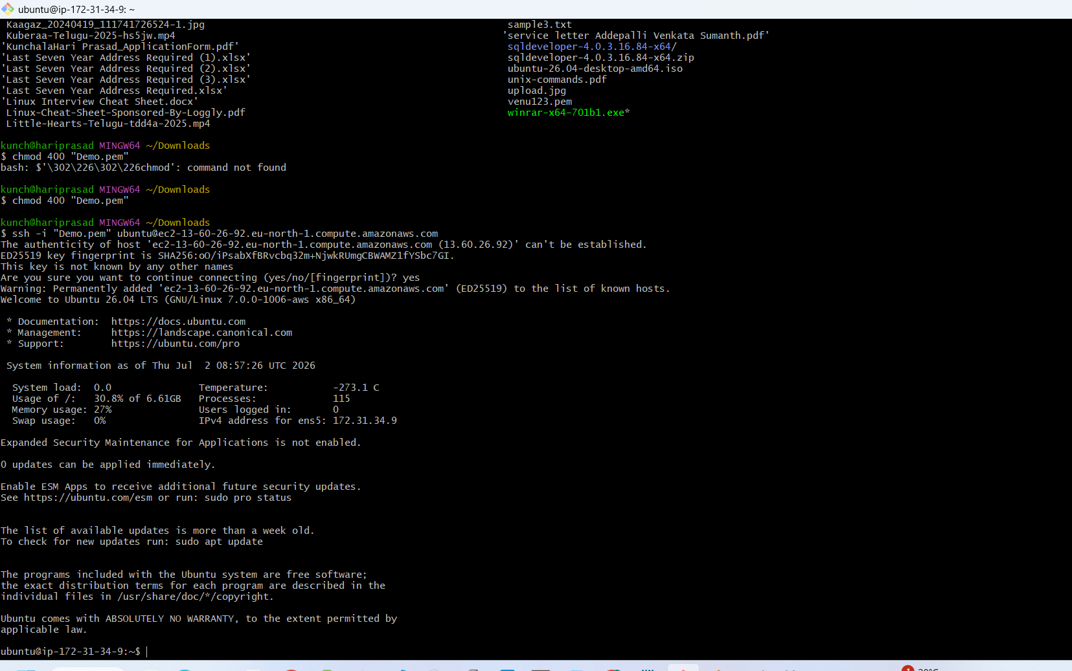

Script1:
By using nano command run “nano bashtest.sh”, next it will nano editor. I have write sample script, It is in below screenshot
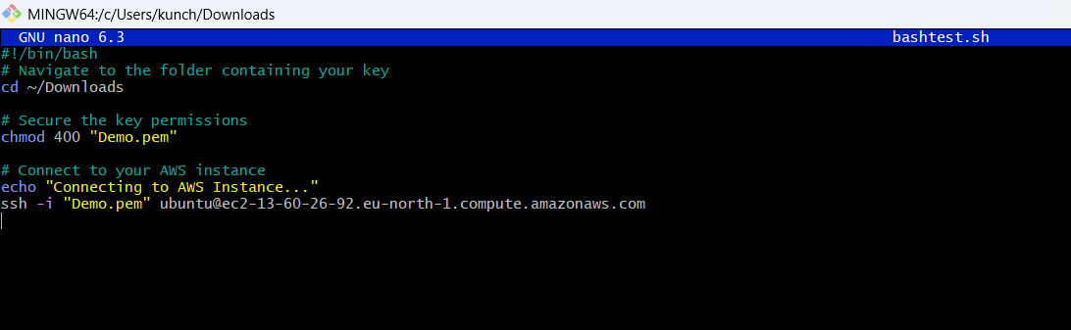

Save and exit the editor by pressing Ctrl + O, then Enter, then Ctrl + X.

Make the script executable by running the command: chmod +x bashtest.sh
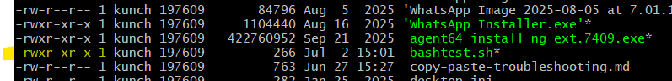
Run script anytime by typing:./bashtest.sh
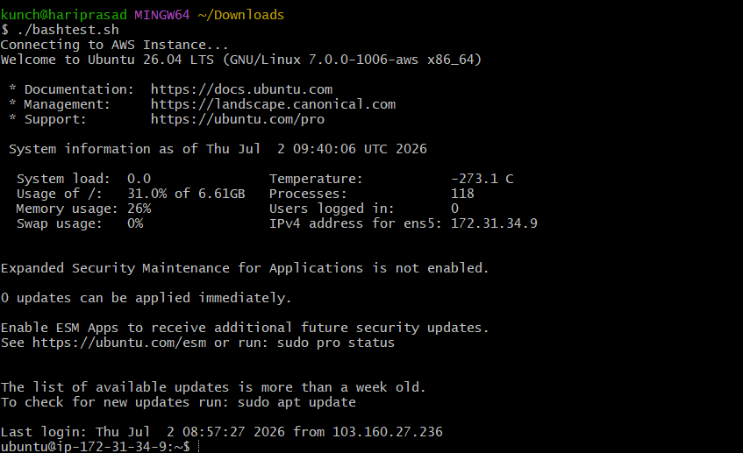
Script2:
- nano hello.sh
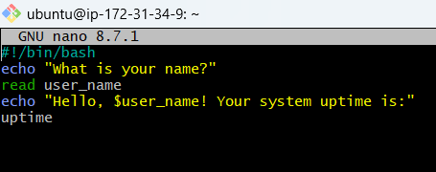

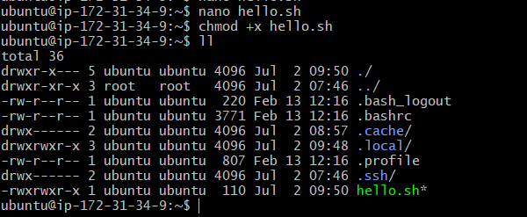

./hello.sh
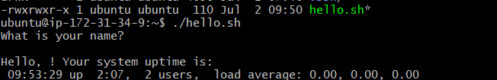

Core Architecture Layers
How a user interacts with a computer through five distinct layers:
- User: The person interacting with the system.
- Application: Software like web browsers, calendars, or text editors.
- Shell: The command interpreter (like bash or a GUI) that translates your inputs into commands.
- Kernel: The core software that acts as the direct interface between software and physical hardware.
- Hardware: Physical components like the CPU, RAM, and hard drives.
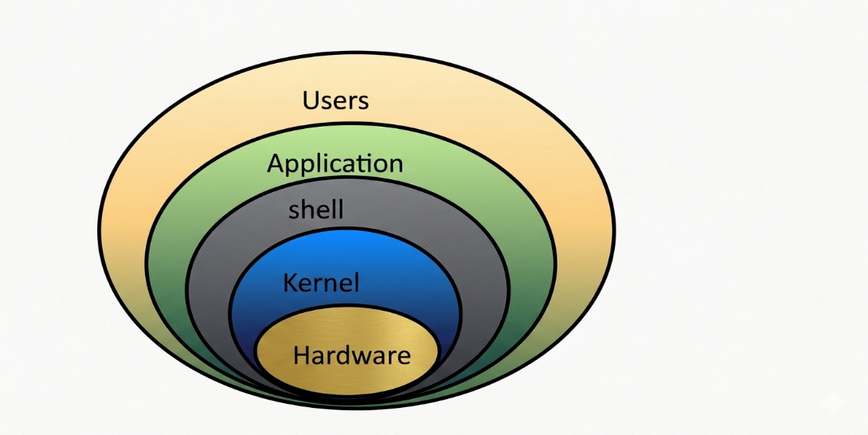
How Commands Execute
When you input or run a command, it moves through the system in this specific order:
- You input a command into an Application or terminal.
- The Shell interprets that command and passes it to the Kernel.
- The Kernel communicates directly with the Hardware to run the physical operations.
- The hardware executes the task and sends the result back up the chain.
What is a Shell?
- An interface between users and the Kernel/OS.
- It can be a Command Line Interface (CLI).
- It can be a Graphical User Interface (GUI).
Commands to Find Your Shell
- echo $0 → Displays the specific shell you are currently using.
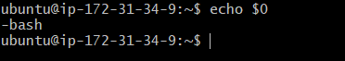
- cat /etc/shells → Lists all available shells installed on the system.
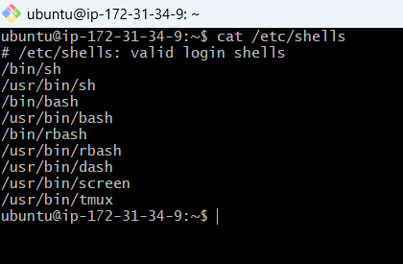
- cat /etc/passwd → Shows the default shell assigned to each user.
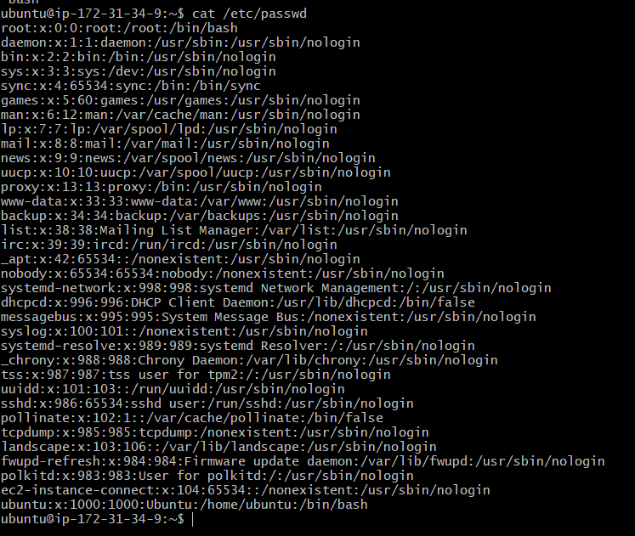

Types of Shells
- Gnome / KDE: Graphical desktop environments (GUIs) used in Linux.
- sh: The original Bourne Shell, developed for Unix by Stephen Bourne.
- Bash: Bourne Again Shell, an enhanced version of the original sh.
- csh / tcsh: C Shell and Tenex C Shell, which use a C-like syntax.
- ksh: Korn Shell, another popular Unix shell.
Starting and Switching Shells
- Every user has a default shell pre-configured by the system.
- You can check this default assignment inside the /etc/passwd file.
- To switch shells, type the name of the new shell (e.g., sh) and press Enter.
- Run echo $0 after switching to confirm the change worked.

Scripting Standards
Script Naming Conventions
- Storage: Always create a dedicated directory to store scripts.
- Clarity: Script names should clearly identify their function.
- Extension: Use standard extensions like .sh or .bash if multiple shells are being utilized.
Standard Script Format
Follow these five essential steps to ensure other users can easily understand your script:
- Define Shell: Start with the shebang line (#!/bin/bash).
- Comments: Include descriptive notes using # comments.
- Define Variables: Declare your data structures early (e.g., name=venu).
- Commands: Execute tasks using standard commands (e.g., echo, cp, grep).
- Statements: Control program flow with logic blocks (e.g., if, while, for).

Here are the industry-standard alternative terms for all five parts:
1. Define Shell (#!/bin/bash)
- Shebang (Most common)
- Hashbang
- Interpreter Directive
- Magic Line
2. Comments (# text)
- Inline Documentation
- Annotations
- Remarks
- Code Notes
3. Define Variables (name=venu)
- Variable Declaration
- Value Assignment
- Identifiers
- Parameters
4. Commands (echo, cp, grep)
- Utilities
- Binaries
- Shell Built-ins (For built-in tools like cd)
- Executables
5. Statements (if, while, for)
- Control Flow
- Control Structures
- Conditional Blocks (Specifically for if)
- Loops (Specifically for while and for)

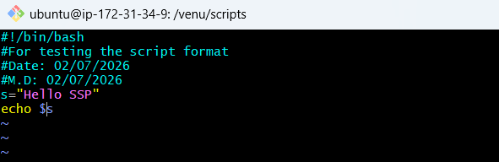
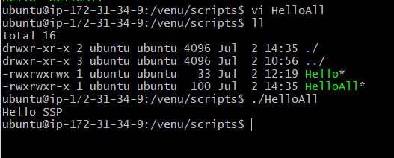

Follow these short, punchy steps to open, edit, and save your file:
1. Open the File
- Run vi filename.sh in your terminal.
- The file opens in Command Mode.
- You cannot type text yet.
2. Enter Edit Mode
- Press i to insert text at the cursor.
- Press a to append text after the cursor.
- Press o to open a new line below.
- Look for -- INSERT -- at the bottom.
3. Type Your Changes
- Type or modify your script text.
- Use arrow keys to navigate around.
- Use Backspace to delete text.
4. Save and Exit
- Press Esc to exit Insert Mode.
- Type :w to save (write) changes.
- Type :q to quit the editor.
- Type :wq to save and quit instantly.
- Type :q! to quit without saving changes.

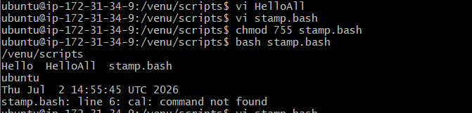
Calendar not installed
Sudo apt update
Sudo apt install ncal
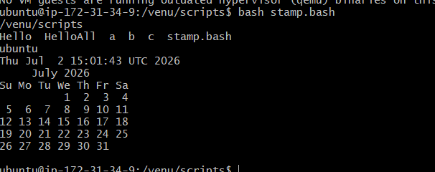

Basic Administration Tasks:
Sample script:
top
df -h
free -m
uptime
iostat

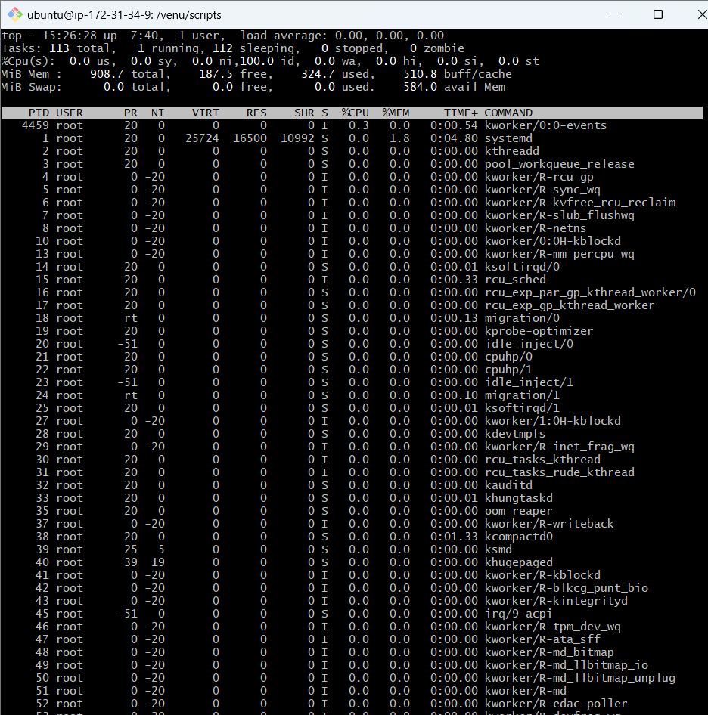

Using head command administration task:
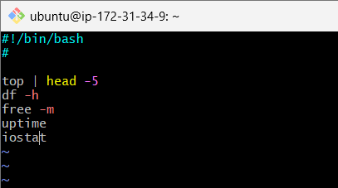
top get stucks because that will conitnously montior.
use top | head -5

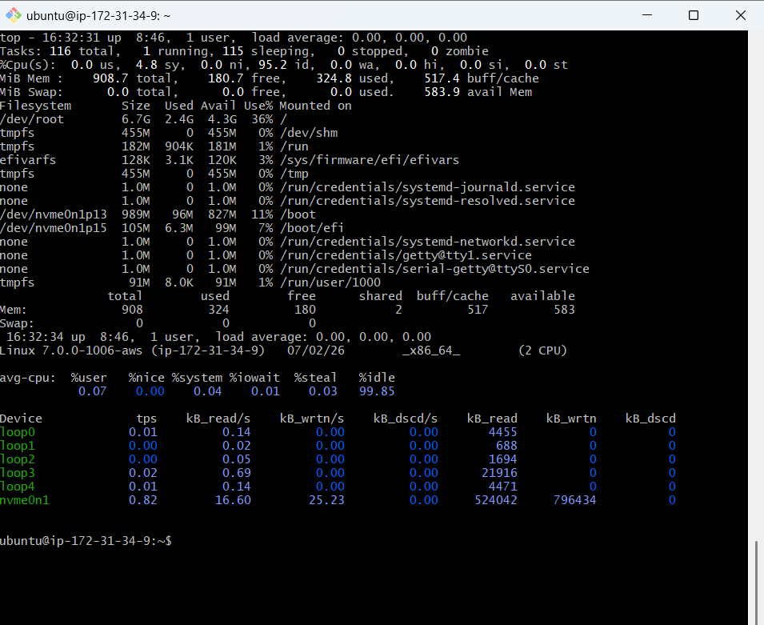

Defining Variables:
In programming, a variable is a value that can change, depending on conditions or on information passed to the program.
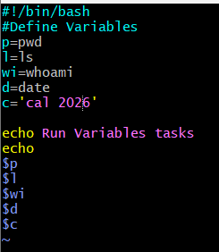
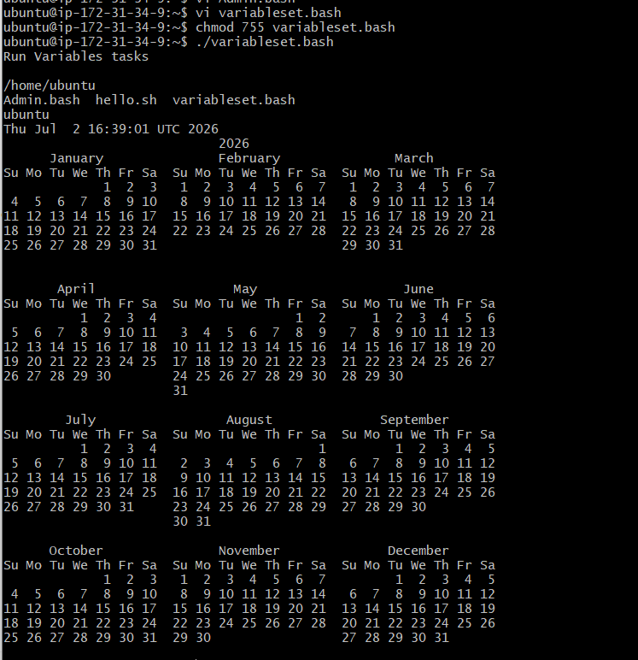

Input/Output script:
1. The read Command (Input)
The read command pauses the script and waits for the user to type something and press Enter. Whatever they type is stored inside a variable.
- Syntax: read variable_name
- Best Practice Flag (-p): Use the -p flag to display a custom prompt message on the screen so the user knows what to type.
2. The echo Command (Output)
The echo command prints text or variable values onto the terminal screen.
- Syntax: echo "Text to print"
- Printing Variables: To print the value stored inside a variable, you must place a dollar sign ($) before the variable name (e.g., $variable_name).
read --> To take command from user
echo --> to print the output
Input:
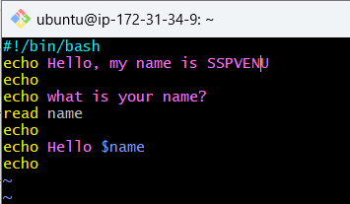
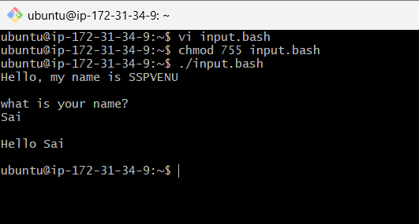

Output:
